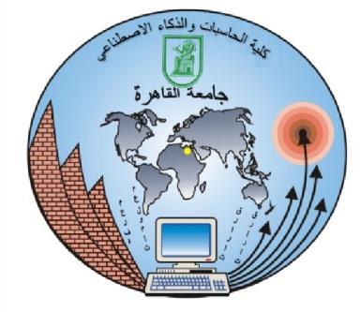**Cairo University,**

**Faculty of Computers and AI**

Web technology

second semester 2022 - 2023

s17

TA. Alaa Adel

student affairs website

project number 2

Phase 2

Mostafa Gamal Mohamed - 20210391

Kariem Gamal Eid Emam - 20210523

Fares Osama - 20210